**Infinite Plate Solution**

The process for a thin film with mixed boundary conditions will be presented. For a thin film, we can apply periodic boundary conditions in $x_{1},x_{2}$ and the following:

$$u_{1}\left(x_{1},x_{2},x_{3}=h_{sub}\right)=0$$

$$u_{2}\left(x_{1},x_{2},x_{3}=h_{sub}\right)=0$$

$$u_{3}\left(x_{1},x_{2},x_{3}=h_{sub}\right)=0,$$

and

$$δσ_{i3}\left(x_{1},x_{2},x_{3}=h_{film}\right)=0$$

$$δσ_{i3}=C_{i3kl}\left(u_{k,l}-ε_{kl}^{0}\right)$$

For a thin film, we simulate a thin film on a substrate. There is also an air overlayer due to the fact that the Fourier transform will, by its nature periodically repeat the data. The thin film boundary conditions correspond to a strain free bottom and a stress free surface. The order parameter, the polarization, is only nonzero within the film (polarization is zero within the air and substrate layers).

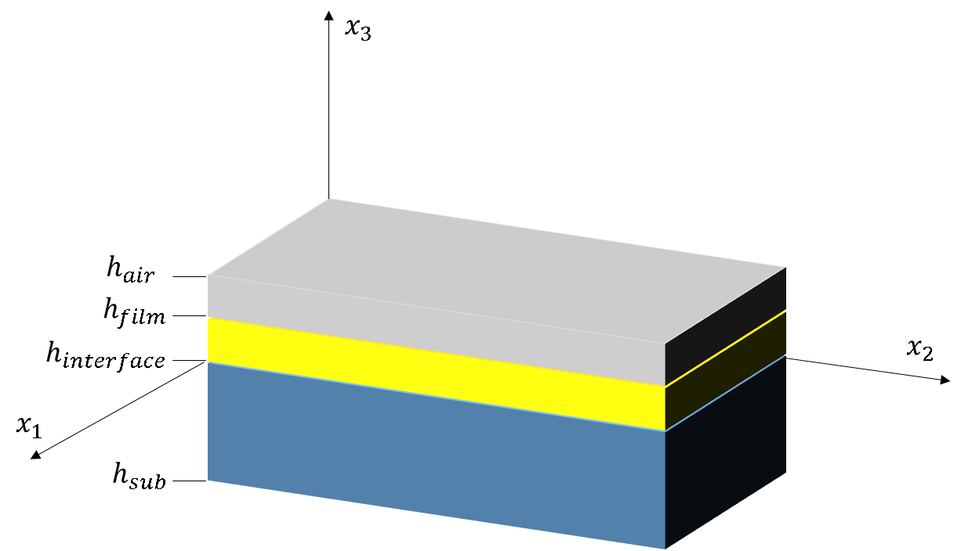

We must also apply macroscopic boundary conditions to the homogenous strain ${\overline{ε}}_{ij}$ and stress ${\overline{σ}}_{ij}$. These are our familiar thin film boundary conditions:

$${\overline{σ}}_{33}={\overline{σ}}_{13}={\overline{σ}}_{23}=0$$

$${\overline{ε}}_{11}={\overline{ε}}_{22}=U_{s}$$

$${\overline{ε}}_{12}=0$$

**Mathematical Solution**

To solve the partial differential equation $$C_{ijkl}u_{k,lj}=C_{ijkl}ε_{kl,j}^{0}$$

with the specified thin film boundary conditions, we designate $u_{k}=u_{k}^{A}+u_{k}^{B}$, such that

$$C_{ijkl}u_{k,lj}^{A}=C_{ijkl}ε_{kl,j}^{0}$$

$$C_{ijkl}u_{k,lj}^{B}=0$$

This solution method is essentially similar to those encountered in ordinary differential equations (ODEs). We have designated a general homogenous solution $u_{k,jl}^{B}$ and a particular solution $u_{k,jl}^{A}.$ The general solution will have undetermined coefficients which we can adjust so that the total solution $u_{k}$ satisfies the given boundary conditions. As an example, consider the 1D ODE $y^{''}\left(x\right)=x.$

* The general solution is $y_{B}\left(x\right)=Ax+B,$ where $A,B$ are constants, because $y_{B}^{''}=0.$
* The particular solution is $y_{A}\left(x\right)=\frac{x^{3}}{6},$ because $\frac{d^{2}}{dx^{2}}y_{A}=x.$
* The complete solution is $y=y_{A}+y_{B}=\frac{x^{3}}{6}+Ax+B.$ For a second order ODE, we specify two boundary conditions. With these boundary conditions, we get a system of linear equations which we can solve to find the constants $A,B.$

For the mechanical equilibrium equation, the particular solution $u_{i}^{A}$ can be solved using Khachaturyan’s or Nambu’s method. We solve for $u_{i}^{A}$ for the entire 3D volume, $h_{sub}<x_{3}<h_{film}$. The eigenstrain is zero outside the film portion of the simulation cell.

For the homogenous solution we apply the following boundary conditions:

$$u_{i}^{B}\left(x_{1},x_{2},x_{3}=h_{sub}\right)=-u_{i}^{A}\left(x_{1},x_{2},x_{3}=h_{sub}\right)$$

$${\tilde{u}}_{i}^{B}\left(η_{1},η_{2},x_{3}=h_{sub}\right)=-{\tilde{u}}_{i}^{A}\left(η_{1},η_{2},x_{3}=h_{sub}\right)$$

$$C_{i3kl}u_{k,l}^{B}=-C_{i3kl}\left(u_{k,l}^{A}-ε_{kl}^{0}\right)$$

To solve the homogenous solution, we define the two dimensional Fourier transform in the *x1* and *x2* axes. Differentiation along *x1* and *x2* in becomes multiplication by $iη_{1}$ and $iη_{2}$ respectively. The homogenous solution simplifies to:

$$C_{iαkβ}\left(iη_{α}\right)\left(iη_{β}\right)\tilde{u}+\left(C_{iαk3}+C_{i3kα}\right)\left(iη_{α}\right){\tilde{u}}_{k,3}^{B}+C_{i3k3}{\tilde{u}}_{k,33}^{B}=0$$

For a given Fourier space point $\left(η_{α},η_{β}\right)$ we have a 1D differential equation in $x_{3}$ only. We can guess a solution ${\tilde{u}}_{k}^{B}\left(η_{α},η_{β},x_{3}\right) =a_{k}e^{ip_{t}x_{3}\sqrt{η_{1}^{2}+η_{2}^{2}}}$. YuLuanLi Acta Materilia 50(2002). Plugging this guessed solution into the PDE, we get a matrix equation…

But in essence, we solve an eigenvalue equation at each 2D Fourier space point to find the constants $a_{k}$ and $p_{k}$. It turns out we have six of these constants for each Fourier space point. We then plug in our calculated values into our exponential guess to recover the full 3D solution.

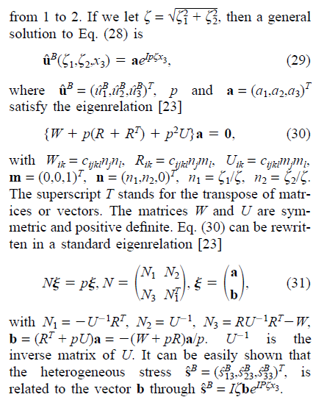

$${δσ}_{i3}^{B}=C_{i3kl}u_{k,l}^{B}=C_{i311}u_{1,1}^{B}+C_{i312}u_{1,2}^{B}+C_{i313}u_{1,3}^{B}+C_{i321}u_{2,1}^{B}+C_{i322}u_{2,2}^{B}+C_{i323}u_{2,3}^{B}+C_{i331}^{B}u_{3,1}+C_{i332}^{B}u_{3,2}+C_{i333}^{B}u_{3,3}$$

$${δσ}_{i3}^{B}+{δσ}_{i3}^{A}=C_{i3kl}ε_{kl}^{0}$$

$${δσ}_{13}^{A}=C_{44}u_{3,1}^{A}+C_{44}u_{1,3}^{A}$$

$${δσ}_{23}^{A}=C_{44}u_{3,2}^{A}+C_{44}u_{2,3}^{A}$$

$${δσ}_{33}^{A}=C_{12}u_{1,1}^{A}+C_{12}u_{2,2}^{A}+C_{11}u_{3,3}^{A}$$

$$F_{2D}\left\{{δσ}_{i3}^{B}+{δσ}_{i3}^{A}=C_{i3kl}ε_{kl}^{0}\right\}$$

$${\tilde{u}}_{k}^{B}\left(η_{α},η_{β},x_{3}\right) =a_{k}e^{ip_{t}x_{3}\sqrt{η_{1}^{2}+η_{2}^{2}}}$$

$$\frac{∂}{∂x_{3}}{\tilde{u}}_{k}^{B}\left(η_{α},η_{β},x_{3}\right) =ip_{t}\sqrt{η_{1}^{2}+η_{2}^{2}}a_{k}e^{ip_{k}x_{3}\sqrt{η_{1}^{2}+η_{2}^{2}}}$$

$$\frac{∂}{∂x_{1}}{\tilde{u}}_{k}^{B}\left(η_{α},η_{β},x_{3}\right) =iη_{1}a_{k}e^{ip_{k}x_{3}\sqrt{η_{1}^{2}+η_{2}^{2}}}$$

$$\frac{∂}{∂x_{2}}{\tilde{u}}_{k}^{B}\left(η_{α},η_{β},x_{3}\right) =iη_{2}a_{k}e^{ip_{k}x_{3}\sqrt{η_{1}^{2}+η_{2}^{2}}}$$

$$C_{44}\frac{∂{\tilde{u}}_{1}^{B}}{∂x_{3}}+C_{44}\frac{∂{\tilde{u}}_{3}^{B}}{∂x_{1}}=F_{2D}\left\{C_{13kl}ε_{kl}^{0}-{δσ}_{13}^{A}\right\}$$

$$C_{44}ip_{t}\sqrt{η_{1}^{2}+η_{2}^{2}}a_{1}e^{ip_{k}x_{3}\sqrt{η_{1}^{2}+η_{2}^{2}}}+C_{44}\frac{∂{\tilde{u}}_{3}^{B}}{∂x_{1}}=F_{2D}\left\{C_{13kl}ε_{kl}^{0}-{δσ}_{13}^{A}\right\}$$

$$C_{44}\frac{∂{\tilde{u}}_{2}^{B}}{∂x_{3}}+C_{44}\frac{∂{\tilde{u}}_{3}^{B}}{∂x_{2}}=F_{2D}\left\{C_{23kl}ε_{kl}^{0}-{δσ}_{23}^{A}\right\}$$

$$C_{44}ip_{t}\sqrt{η_{1}^{2}+η_{2}^{2}}a_{2}e^{ip_{k}x_{3}\sqrt{η_{1}^{2}+η_{2}^{2}}}+C_{44}\frac{∂{\tilde{u}}_{3}^{B}}{∂x_{2}}=F_{2D}\left\{C_{23kl}ε_{kl}^{0}-{δσ}_{23}^{A}\right\}$$

$$C_{12}\frac{∂{\tilde{u}}_{1}^{B}}{∂x_{1}}+C_{12}\frac{∂{\tilde{u}}_{2}^{B}}{∂x_{2}}+C_{11}\frac{∂{\tilde{u}}_{3}^{B}}{∂x_{3}}=F_{2D}\left\{C_{33kl}ε_{kl}^{0}-{δσ}_{33}^{A}\right\}$$

$$C_{12}\frac{∂{\tilde{u}}_{1}^{B}}{∂x_{1}}+C_{12}\frac{∂{\tilde{u}}_{2}^{B}}{∂x_{2}}+C_{11}ip_{t}\sqrt{η_{1}^{2}+η_{2}^{2}}a_{3}e^{ip_{k}x_{3}\sqrt{η_{1}^{2}+η_{2}^{2}}}=F_{2D}\left\{C_{33kl}ε_{kl}^{0}-{δσ}_{33}^{A}\right\}$$

$$C_{44}ip_{t}\sqrt{η_{1}^{2}+η_{2}^{2}}a_{1}e^{ip_{k}x_{3}\sqrt{η_{1}^{2}+η_{2}^{2}}}+C_{44}\frac{∂{\tilde{u}}_{3}^{B}}{∂x_{1}}=F_{2D}\left\{C_{13kl}ε_{kl}^{0}-{δσ}_{13}^{A}\right\}$$

$$C_{44}ip_{t}\sqrt{η_{1}^{2}+η_{2}^{2}}a_{2}e^{ip_{k}x_{3}\sqrt{η_{1}^{2}+η_{2}^{2}}}+C_{44}\frac{∂{\tilde{u}}_{3}^{B}}{∂x_{2}}=F_{2D}\left\{C_{23kl}ε_{kl}^{0}-{δσ}_{23}^{A}\right\}$$

$$C_{12}\frac{∂{\tilde{u}}_{1}^{B}}{∂x_{1}}+C_{12}\frac{∂{\tilde{u}}_{2}^{B}}{∂x_{2}}+C_{11}ip_{t}\sqrt{η_{1}^{2}+η_{2}^{2}}a_{3}e^{ip_{k}x_{3}\sqrt{η_{1}^{2}+η_{2}^{2}}}=F_{2D}\left\{C_{33kl}ε_{kl}^{0}-{δσ}_{33}^{A}\right\}$$

$$\frac{∂}{∂x_{1}}{\tilde{u}}_{k}^{B}\left(η_{α},η_{β},x_{3}\right) =iη_{1}a_{k}e^{ip_{k}x_{3}\sqrt{η_{1}^{2}+η_{2}^{2}}}$$

$$\frac{∂}{∂x_{2}}{\tilde{u}}_{k}^{B}\left(η_{α},η_{β},x_{3}\right) =iη_{2}a_{k}e^{ip_{k}x_{3}\sqrt{η_{1}^{2}+η_{2}^{2}}}$$

$$C_{44}ip_{t}\sqrt{η_{1}^{2}+η_{2}^{2}}a_{1}e^{ip_{k}x_{3}\sqrt{η_{1}^{2}+η_{2}^{2}}}+C_{44}iη_{1}a_{3}e^{ip_{k}x_{3}\sqrt{η_{1}^{2}+η_{2}^{2}}}=F_{2D}\left\{C_{13kl}ε_{kl}^{0}-{δσ}_{13}^{A}\right\}$$

$$C_{44}ip_{t}\sqrt{η_{1}^{2}+η_{2}^{2}}a_{2}e^{ip_{k}x_{3}\sqrt{η_{1}^{2}+η_{2}^{2}}}+C_{44}iη_{2}a_{2}e^{ip_{k}x_{3}\sqrt{η_{1}^{2}+η_{2}^{2}}}=F_{2D}\left\{C_{23kl}ε_{kl}^{0}-{δσ}_{23}^{A}\right\}$$

$$C_{12}iη_{1}a_{1}e^{ip_{k}x_{3}\sqrt{η_{1}^{2}+η_{2}^{2}}}+C_{12}iη_{2}a_{2}e^{ip_{k}x_{3}\sqrt{η_{1}^{2}+η_{2}^{2}}}+C_{11}ip_{t}\sqrt{η_{1}^{2}+η_{2}^{2}}a_{3}e^{ip_{k}x_{3}\sqrt{η_{1}^{2}+η_{2}^{2}}}=F_{2D}\left\{C_{33kl}ε_{kl}^{0}-{δσ}_{33}^{A}\right\}$$

$$x_{3}=h_{sub}$$

$$a_{1}e^{ip_{t}x_{3}\sqrt{η_{1}^{2}+η_{2}^{2}}}={\tilde{u}}_{1}^{A}(η_{1},η_{2},x_{3}=h_{sub})$$

$$a_{2}e^{ip_{t}x_{3}\sqrt{η_{1}^{2}+η_{2}^{2}}}={\tilde{u}}_{2}^{A}(η_{1},η_{2},x_{3}=h_{sub})$$

$$a_{3}e^{ip_{t}x_{3}\sqrt{η_{1}^{2}+η_{2}^{2}}}={\tilde{u}}_{3}^{A}(η_{1},η_{2},x_{3}=h_{sub})$$

With $x_{3}=h_{film}$

$$i\sqrt{η_{1}^{2}+η_{2}^{2}}p_{t}a_{1}e^{ip_{k}x_{3}\sqrt{η_{1}^{2}+η_{2}^{2}}}+{\left.\frac{∂{\tilde{u}}_{3}^{B}}{∂x_{1}}\right|}_{x_{3}}=\frac{1}{C_{44}}F_{2D}\left\{C_{13kl}ε_{kl}^{0}-{δσ}_{13}^{A}\right\}$$

$$i\sqrt{η_{1}^{2}+η_{2}^{2}}p_{t}a_{2}e^{ip_{k}x_{3}\sqrt{η_{1}^{2}+η_{2}^{2}}}+{\left.\frac{∂{\tilde{u}}_{3}^{B}}{∂x_{2}}\right|}_{x_{3}}=\frac{1}{C_{44}}F_{2D}\left\{C_{23kl}ε_{kl}^{0}-{δσ}_{23}^{A}\right\}$$

$$i\sqrt{η_{1}^{2}+η_{2}^{2}}p_{t}a_{3}e^{ip_{k}x_{3}\sqrt{η_{1}^{2}+η_{2}^{2}}}+\frac{C_{12}}{C_{11}}{\left.\frac{∂{\tilde{u}}_{1}^{B}}{∂x_{1}}\right|}_{x_{3}}-\frac{C_{12}}{C_{11}}{\left.\frac{∂{\tilde{u}}_{2}^{B}}{∂x_{2}}\right|}_{x_{3}}=\frac{1}{C_{11}}F_{2D}\left\{C_{33kl}ε_{kl}^{0}-{δσ}_{33}^{A}\right\}$$

Our eigenvalues cannot be found at the 2D Fourier space origin, $η_{1}=η_{2}=0,$

As such, our exponential solution is no good. Instead the equation becomes

$$C_{i3k3}{\tilde{u}}_{k,33}^{B}=0.$$

The solutions become:

$${\tilde{u}}_{k=1}^{B}(η_{1},η_{2},x_{3})=Ax_{3}+B$$

$${\tilde{u}}_{k=2}^{B}(η_{1},η_{2},x_{3})={Cx}_{3}+D$$

$${\tilde{u}}_{k=3}^{B} (η_{1},η_{2},x_{3})=Ex_{3}+F$$

The heterogeneous stress is given by:

$${δσ}_{i3}^{B}=C_{i3kl}u_{k,l}^{B}.$$

$${δσ}_{i3}^{B}=C_{i3kl}u_{k,l}^{B}=C_{i311}u_{1,1}^{B}+C_{i312}u_{1,2}^{B}+C_{i313}u_{1,3}^{B}+C_{i321}u_{2,1}^{B}+C_{i322}u_{2,2}^{B}+C_{i323}u_{2,3}^{B}+C_{i331}^{B}u_{3,1}+C_{i332}^{B}u_{3,2}+C_{i333}^{B}u_{3,3}$$

When we 2D Fourier transform in $x_{1}$ and $x_{2}$, the derivatives with respect to $x_{1}$ and $x_{2}$ become multiplication by ${iη}_{1}$ and ${iη}_{2}$ respectively. But at the 2D Fourier space origin,

$$η_{1}=η_{2}=0.$$

So at the 2D Fourier space origin the equation simplifies to:

$${δσ}_{i3}^{B}\left(η_{1}=0,η_{2}=0, x_{3}\right)=C_{i313}u_{1,3}^{B}+C_{i323}u_{2,3}^{B}+C_{i333}^{B}u_{3,3}=C_{i313}A+C_{i323}C+C_{i333}E,$$

with $i$ ranging from 1 through 3. The derivative of the guessed solution with respect to the z axis is a constant.

At the substrate, where $x_{3}=h_{sub}$,

$${\tilde{u}}_{k=1}^{B}(η_{1}=0,η_{2}=0,x_{3}=h_{sub})=Ah_{sub}+B$$

$${\tilde{u}}_{k=2}^{B}(η_{1}=0,η_{2}=0,x_{3}=h_{sub})=Ch_{sub}+D$$

$${\tilde{u}}_{k=3}^{B}(η_{1}=0,η_{2}=0,x_{3}=h_{sub})=Eh_{sub}+F$$

In the thin film boundary conditions:

$${δσ}_{i3}^{B}\left(η_{1}=0,η_{2}=0, x_{3}=h_{film}\right)=-C_{i3kl}\left({\hat{u}}_{k,l}^{A}\left(0,0,h_{film}\right)-{\hat{ε}}_{k,l}^{0}\left(0,0,h_{film}\right)\right)$$

$${\hat{u}}_{k}^{B}\left(η_{1}=0,η_{2}=0,x_{3}=h_{sub}\right)=-{\hat{u}}_{k}^{A}(0,0,h_{sub})$$

Therefore, we have:

$$Ah_{sub}+B=-{\hat{u}}_{1}^{A}(0,0,h_{sub})$$

$$Ch_{sub}+D=-{\hat{u}}_{2}^{A}(0,0,h_{sub})$$

$$Eh_{sub}+F=-{\hat{u}}_{3}^{A}(0,0,h_{sub})$$

$$C_{1313}A+C_{1323}C+C_{1333}E=-C_{13kl}\left({\hat{u}}_{k,l}^{A}\left(0,0,h_{film}\right)-{\hat{ε}}_{k,l}^{0}\left(0,0,h_{film}\right)\right)$$

$$C_{2313}A+C_{2323}C+C_{2333}E=-C_{23kl}\left({\hat{u}}_{k,l}^{A}\left(0,0,h_{film}\right)-{\hat{ε}}_{k,l}^{0}\left(0,0,h_{film}\right)\right)$$

$$C_{3313}A+C_{3323}C+C_{3333}E=-C_{33kl}\left({\hat{u}}_{k,l}^{A}\left(0,0,h_{film}\right)-{\hat{ε}}_{k,l}^{0}\left(0,0,h_{film}\right)\right)$$

We can recast into the following matrix:

$$\left[\begin{matrix}h_{sub} & 1 & 0 & 0 & 0 & 0 \\ 0 & 0 & h_{sub} & 1 & 0 & 0 \\ 0 & 0 & 0 & 0 & h_{sub} & 1 \\ C_{1313} & 0 & C_{1323} & 0 & C_{1333} & 0 \\ C_{2313} & 0 & C_{2323} & 0 & C_{2333} & 0 \\ C_{3313} & 0 & C_{3323} & 0 & C_{3333} & 0\end{matrix}\right]\left[\begin{matrix}A \\ B \\ \begin{matrix}C \\ D \\ \begin{matrix}E \\ F\end{matrix}\end{matrix}\end{matrix}\right]=\left[\begin{matrix}-{\hat{u}}_{1}^{A}(0,0,h_{sub}) \\ -{\hat{u}}_{2}^{A}(0,0,h_{sub}) \\ \begin{matrix}-{\hat{u}}_{3}^{A}(0,0,h_{sub}) \\ -C_{13kl}\left({\hat{u}}_{k,l}^{A}\left(0,0,h_{film}\right)-{\hat{ε}}_{k,l}^{0}\left(0,0,h_{film}\right)\right) \\ \begin{matrix}-C_{23kl}\left({\hat{u}}_{k,l}^{A}\left(0,0,h_{film}\right)-{\hat{ε}}_{k,l}^{0}\left(0,0,h_{film}\right)\right) \\ -C_{33kl}\left({\hat{u}}_{k,l}^{A}\left(0,0,h_{film}\right)-{\hat{ε}}_{k,l}^{0}\left(0,0,h_{film}\right)\right)\end{matrix}\end{matrix}\end{matrix}\right]$$